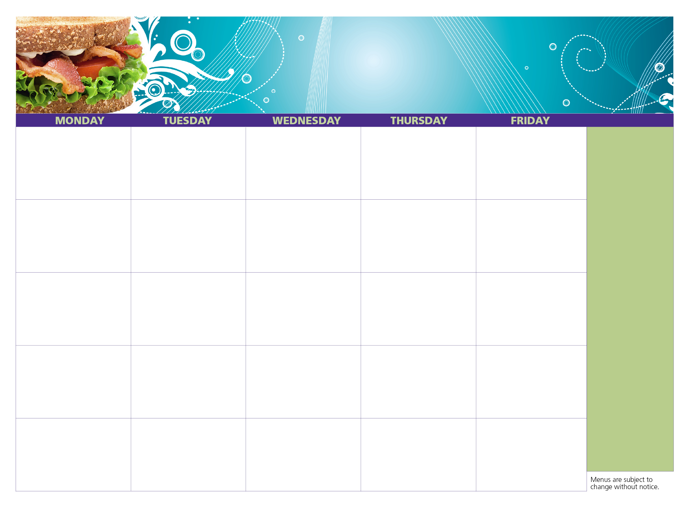

We offer free, nutritious meals to all teens & children, 18 & under – no ID or paperwork required!

**Jesse Smith Library**

**Open Site**

**Serving Lunch**

**From 12pm to 1pm**

**Under Pavilion**

**100 Tinkham Lane**

**Harrisville, RI**

For more information on summer meals programs and to find the site nearest you, **call 211\***

Chicken Salad Sandwich

Mixed Fruit

Orange Juice

Milk

**Did you know?**

**Burrillville Summer Cold Lunch Program**

**31**

**24**

**Healthy Kids. Healthy Communities. Healthy Rhode Island!**

Turkey & Cheese Sandwich

Diced Pineapple

Apple Juice

Milk

Chicken Salad Sandwich

Baby Carrots

Apple Juice

Milk

Bagel Fun Lunch

Applesauce

Orange Juice

Milk

Turkey & Cheese Sandwich

Mixed Fruit

Apple Juice

Milk

**13**

**12**

**11**

**10**

**9**

Ham & Cheese Sandwich

Diced Pears

Orange Juice

Milk

**2**

**5**

**19**

**26**

**3**

**4**

**18**

**25**

**17**

Turkey & Cheese Sandwich

Diced Pear

Orange Juice

Milk

Chicken Caesar Wrap

Raisins

Apple Juice

Milk

**20**

**16**

Bagel Fun Lunch

Raisins

Apple Juice

Milk

Bagel Fun Lunch

Baby Carrots

Apple Juice

Milk

Chicken Ranch Sub

Baby Carrots

Orange Juice

Milk

Turkey & Cheese Sub

Mixed Fruit

Apple Juice

Milk

**27**

**23**

Chicken Caesar Wrap

Applesauce

Orange Juice

Milk

Chicken Salad Sandwich

Craisins

Apple Juice

Milk

Ham & Cheese Sandwich

Diced Pears

Apple Juice

Milk

**1**

**30**

Honey Mustard Chicken Sandwich

Raisins

Apple Juice

Milk

Chicken Ranch Sub

Baby Carrots

Orange Juice

Milk

Chicken Salad Sandwich

Pear

Orange Juice

Milk

Turkey & Cheese Sandwich

Mixed Fruit

Apple Juice

Milk

Bagel Fun Lunch

Applesauce

Orange Juice

Milk

**3**

**6**

July 4th

**2**

**July**

**2018**