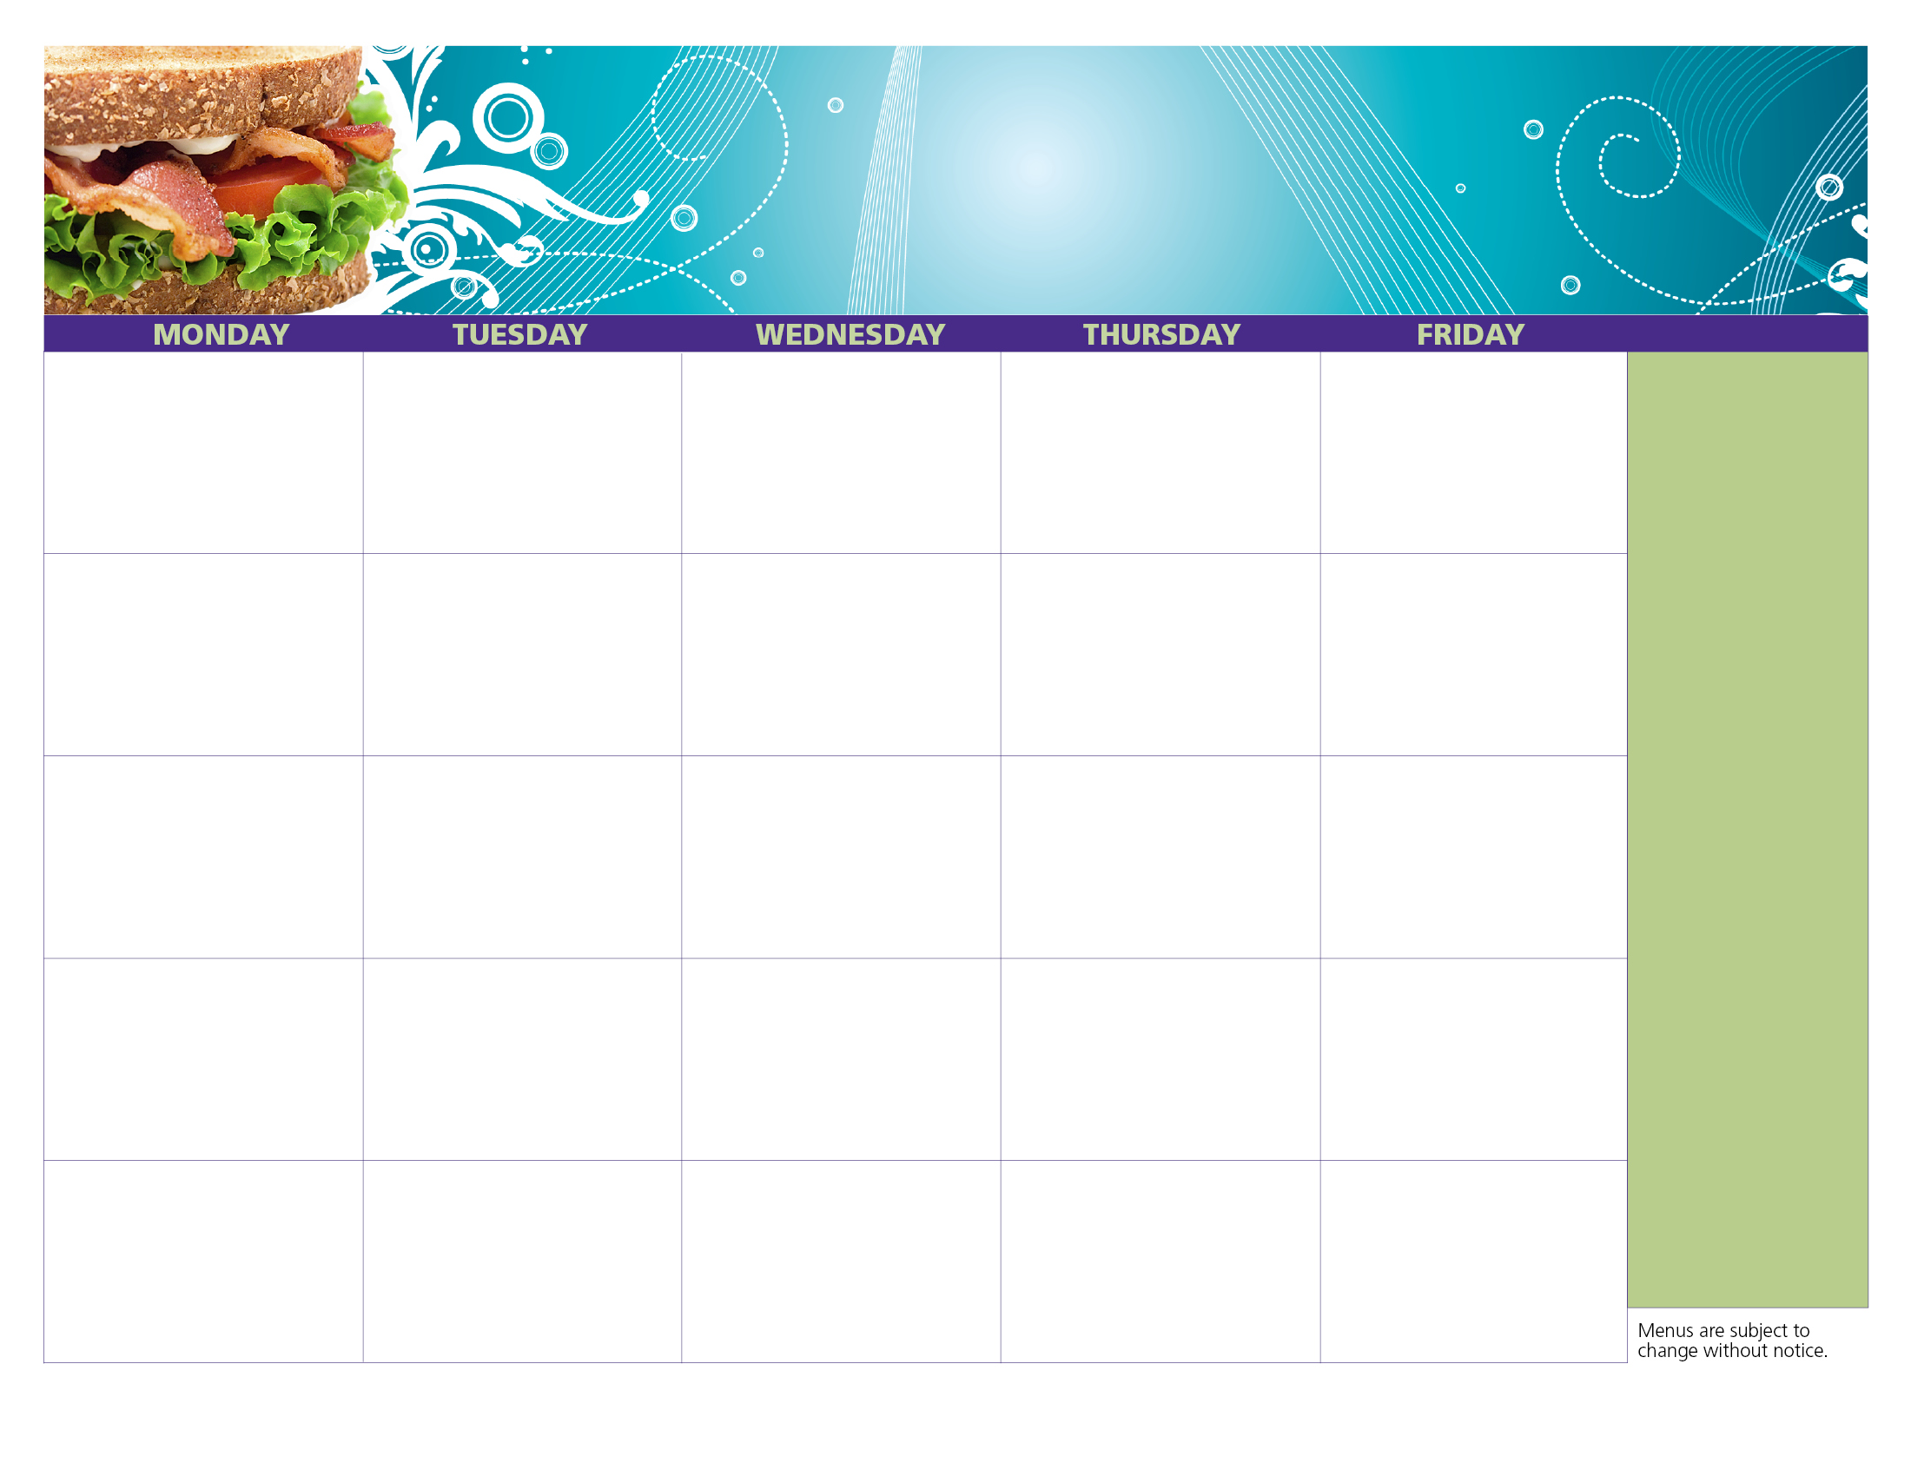

We offer free, nutritious meals to all teens & children, 18 & under – no ID or paperwork required!

**Jesse Smith Library**

**Open Site**

**Serving Lunch**

**From 12pm to 1pm**

**Under Pavilion**

**100 Tinkham Lane**

**Harrisville, RI**

For more information on summer meals programs and to find the site nearest you, **call 211\***

Chicken Salad Sandwich

Cherry Tomatoes

Orange Juice

Milk

**Did you know?**

**Burrillville Summer Cold Lunch Program**

**28**

**21**

**Healthy Kids. Healthy Communities. Healthy Rhode Island!**

Turkey & Cheese Sandwich

Diced Pineapple

Apple Juice

Milk

Chicken Salad Sandwich

Baby Carrots

Apple Juice

Milk

Bagel Fun Lunch

Applesauce

Orange Juice

Milk

Turkey & Cheese Sandwich

Mixed Fruit

Apple Juice

Milk

**10**

**9**

**8**

**7**

**6**

Ham & Cheese Sandwich

Diced Pears

Orange Juice

Milk

**30**

**2**

**16**

**23**

**31**

**1**

**15**

**22**

**14**

Turkey & Cheese Sandwich

Diced Pear

Orange Juice

Milk

VJ Day

No Service

**17**

**13**

Ham & Cheese Sandwich

Craisins

Orange Juice

Milk

Bagel Fun Lunch

Baby Carrots

Apple Juice

Milk

Chicken Ranch Sub

Raisins

Orange Juice

Milk

Turkey & Cheese Sub

Diced Pear

Apple Juice

Milk

**24**

**20**

Bagel Fun Lunch

Apple

Orange Juice

Milk

Chicken Salad Sandwich

Mixed Fruit

Apple Juice

Milk

Ham & Cheese Sandwich

Baby Carrots

Apple Juice

Milk

**29**

**27**

**31**

**3**

Chicken Ranch Sub

Baby Carrots

Orange Juice

Milk

Honey Mustard Chicken Sandwich

Raisins

Apple Juice

Milk

Chicken Salad Sandwich

Pear

Orange Juice

Milk

**30**

**August**

**2018**